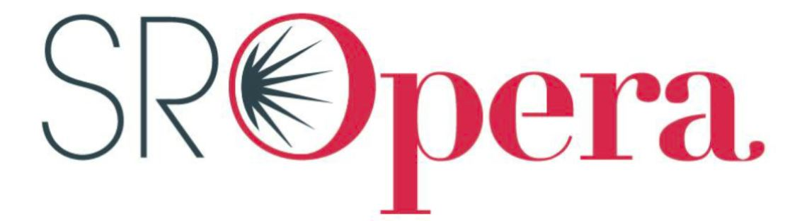

Springfield Regional Opera Advertising

Business Name: ______________________________________________________________________________________________________

Billing Address: ______________________________________________________________________________________________________

Phone Number: __________________________________________ Fax Number: ___________________________________________

Email: _______________________________________________________ Website:_____________________________________________

Representative: _____________________________________________________________________________________________________

Signature: ____________________________________________________________________________________________________________

Your ad will appear in all Springfield Regional Opera event programs during the season including operas, concerts, and special events. The typical opera audience comprises established professionals and retirees with significant income as well as a strong collegiate and early professional presence.
Please circle the size of the promotion space you wish to purchase.
Size | Height and Width | Rate
Quarter Page Horizontal | 4 ½ inch x 1 ¾ inch | $380
Quarter Page Vertical | 2 1/8 inch x 3 5/8 inch | $380
Half Page  Horizontal | 4 ½ inch x 3 5/8 inch | $480
Half Page  Vertical | 2 ¼ inch x 7 ½ inch | $480
Full Page | 4 ½ inch x 7 ½ inch | $780
Inside Front Cover | 4 ½ inch x 7 ½ inch | $1000
Inside Back Cover | 4 ½ inch x 7 ½ inch | $1000
Please check one of the following. All copy and payments are due by September 1. Files must be at least 300 dpi. Send your camera-ready art to administration@sropera.org

❑ Renewal: Copy and/or Camera Ready Art included
❑ Renewal: New Copy and /or Camera Ready Art will be provided
❑ New: New Copy and/or Camera Ready Art included
❑ New: New Copy and /or Camera Ready Art will be provided
❑ Contact me about creating a unique ad for my business.
Terms: Purchaser agrees to pay for promotion space in the SRO program book upon signing this contract.
Make checks payable to: “Springfield Regional Opera” and mail to:
Springfield Regional Opera
Attn: Sean Spyres
411 North Sherman Parkway
Springfield, MO 65802
(417) 863-1960
www.sropera.org
info@sropera.org

